**NATIONAL UNIVERSITY OF COMPUTER AND EMERGING SCIENCES- FAST**

**KARACHI CAMPUS**



**NETWORK DESIGN OF HOTEL MANAGEMENT SYSTEM**

**COURSE INSTRUCTOR: Sir Kariz Kamal**

**COMPUTER NETWORKS LAB SECTION: C**

**GROUP MEMBERS:**

**<Fatima Ibrahim, 17K-3639>**

**<Eisha Tir Raazia 17K-3730>**

**<Maham Tariq 17K-3658>**

**<Ammar 17K-2375>**

TABLE OF CONTENTS:

ABSTRACT 3

NETWORK REQUIREMENTS 3

FEATURES AND SERVICES 3

NETWORK DESIGN 4

IP NETWORK POOL: 4

SUMMARY: 4

# ABSTRACT:

This report describes the network design of a hotel management system. The network design has been made and simulated on Cisco Packet Tracer. The network topology is consisting of different departments. The devices used in this network design are:

* Routers
* Switches
* Servers for DNS,HTTP,FTP

There are following departments in the design:

* Food Quality
* Security
* Operations department
* Accounts
* Main Lobby (The reception which have access to all departments)

# NETWORK REQUIREMENTS:

In hotel, we have different departments and those departments have different end devices such as desktops, laptops and phone. There will be a data flow between the devices within the system. A dns and http server is needed to access the website of our hotel from all departments. The file server is needed so that every department have a shared server which can be used to get and put files on that server. And, VOIP is needed for phone call system.

# FEATURES AND SERVICES:

* DHCP
* FTP
* DNS
* HTTP
* Telnet
* Routing by RIP V2

# NETWORK DESIGN:

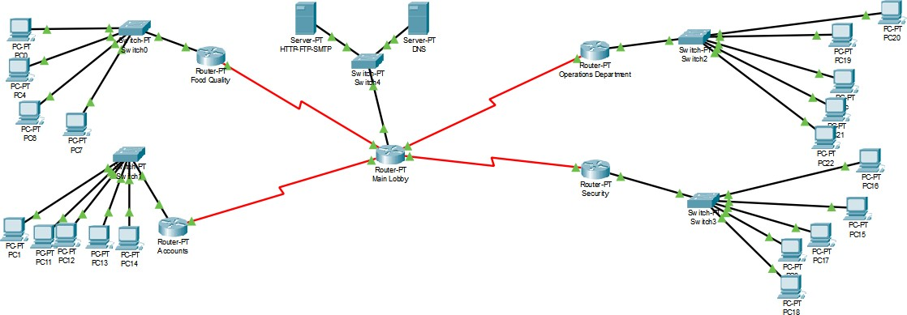

# IP NETWORK POOL:

The network pool here used is 192.168.1.0.

|  |  |  |
| --- | --- | --- |
| **DEPARMENTS** | **NETWORK ADDRESS** | **HOSTS NEEDED** |
| **Food Quality** | 192.168.1.40/29 | 5 |
| **Accounts** | 192.168.1.30/29 | 5 |
| **Operations** | 192.168.1.48/29 | 5 |
| **Security** | 192.168.1.56/29 | 5 |
| **Main Lobby** | 192.168.1.64 | 5 |

# SUMMARY:

## This report describes how we have designed network topology of hotel. We have used one network pool and FLSM for submitting. The network requirements are network devices, security and dataflow.